PROJECT REPORT

1. Introduction

INDIA’S AGRICULTURE CROPS PRODUCTION ANALYSIS

Agriculture is a significant part of the india economy,accounting for over 17% of total GDP and employing moe than 6% of the population .over the last views decades,india’s agriculture has grown at a rapid peace and has made a global mark mainly due to the rapid growth

* 1. OVERVIEW

Agriculuture is an evolutionary process that consist of a series of activities such as the production of food,fibers,feed,and raising of domesticated animals to fulfill the demand of the population

* 1. PURPOSE

Agriculture impacts society in many ways,including supporting livelihood through food ,habitat,and jobs;providing raw materials for food and other products;and building strong economics through trade

2.Problem definition&desing thinking

The present challenges that plague Indian agriculture ae limited knowledge and in suffient infastucture ,especially in the ural area

\*Design thining

Designing farming equipment ;desing thinking can be used to design farming equipment that is more efficient,safer ,and easier to use

* 1. Emapathy map

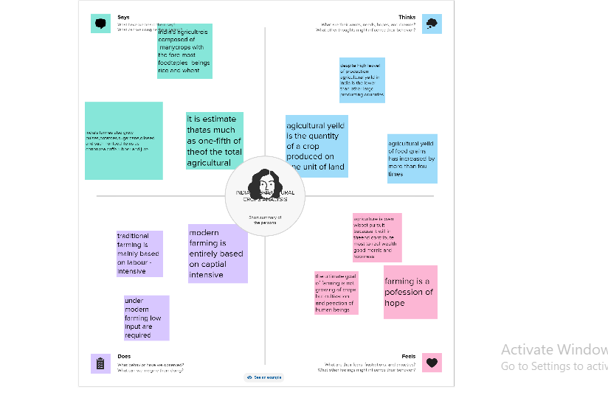

* 1. ideation& brainstorming map

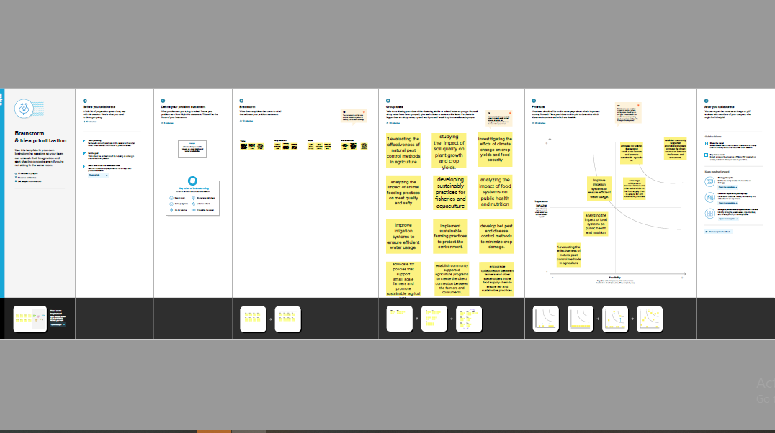

3.Result

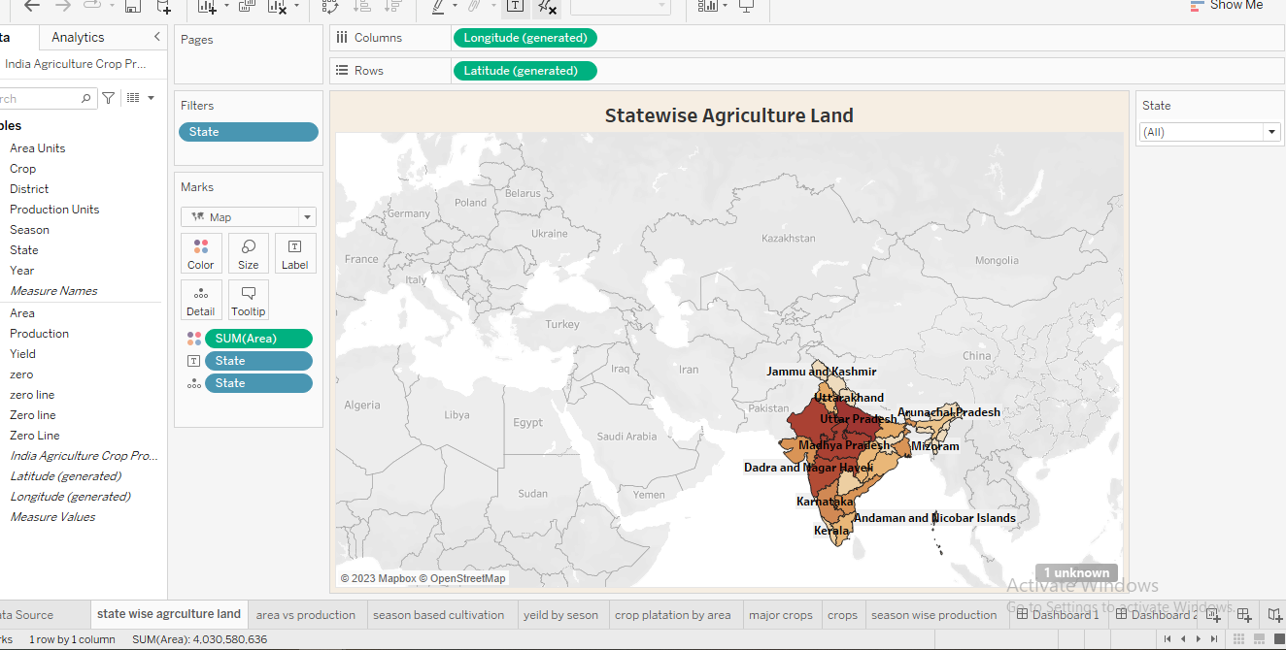

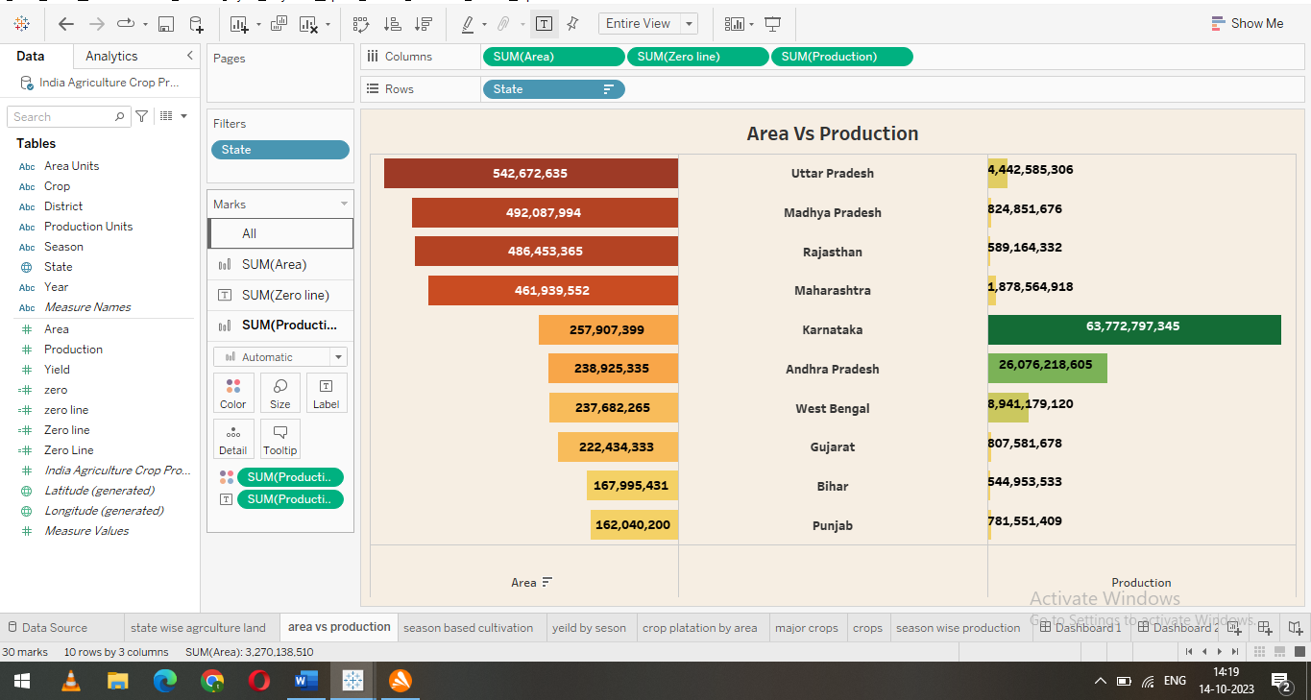

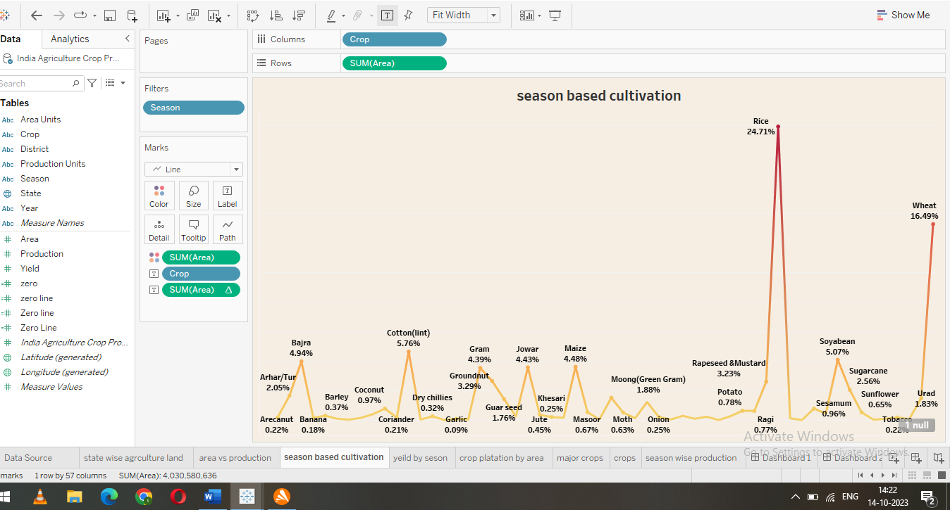

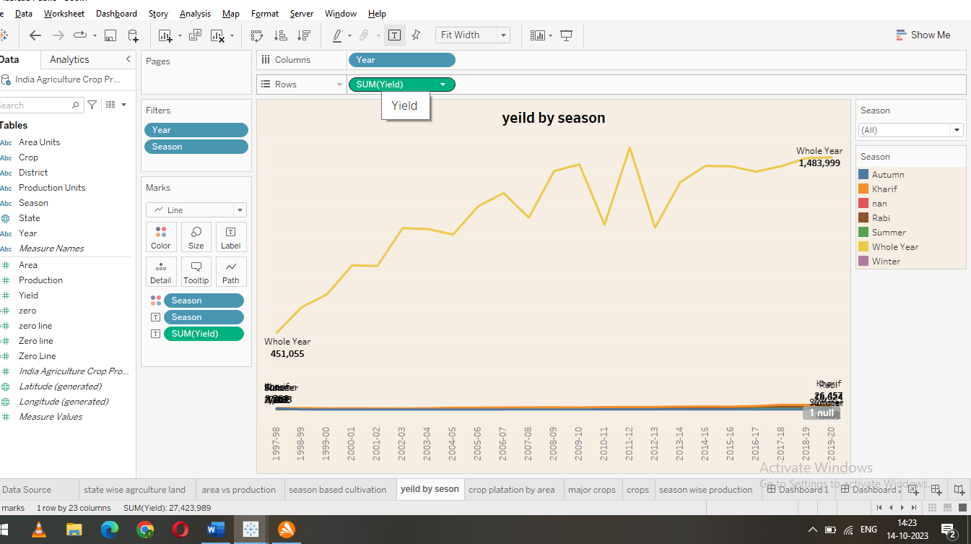

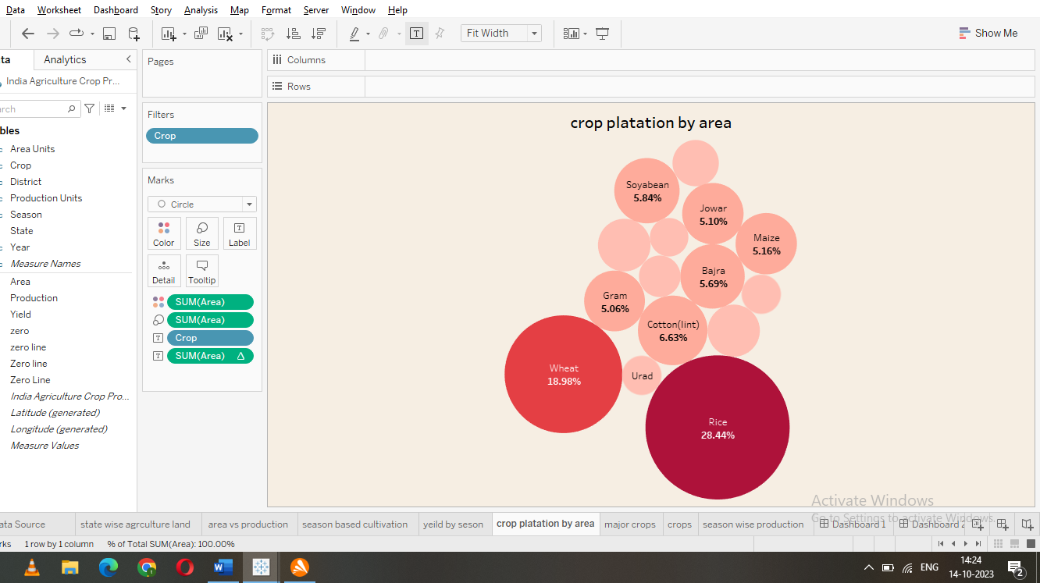

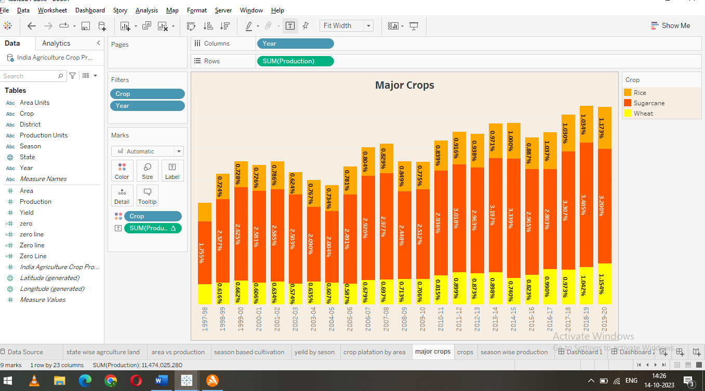

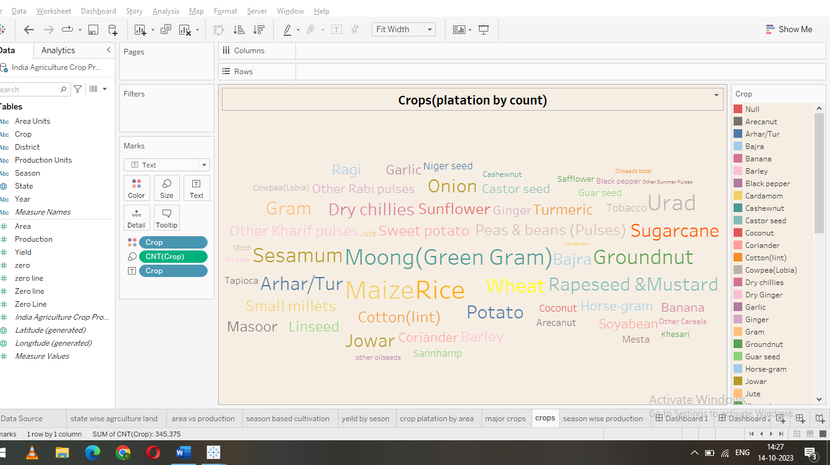

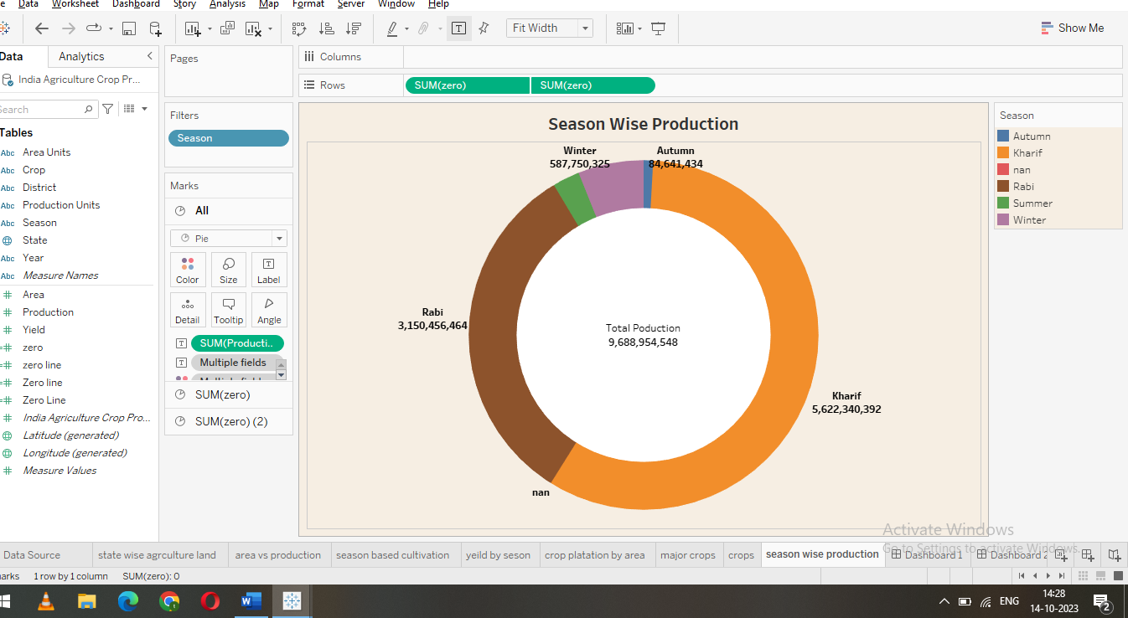

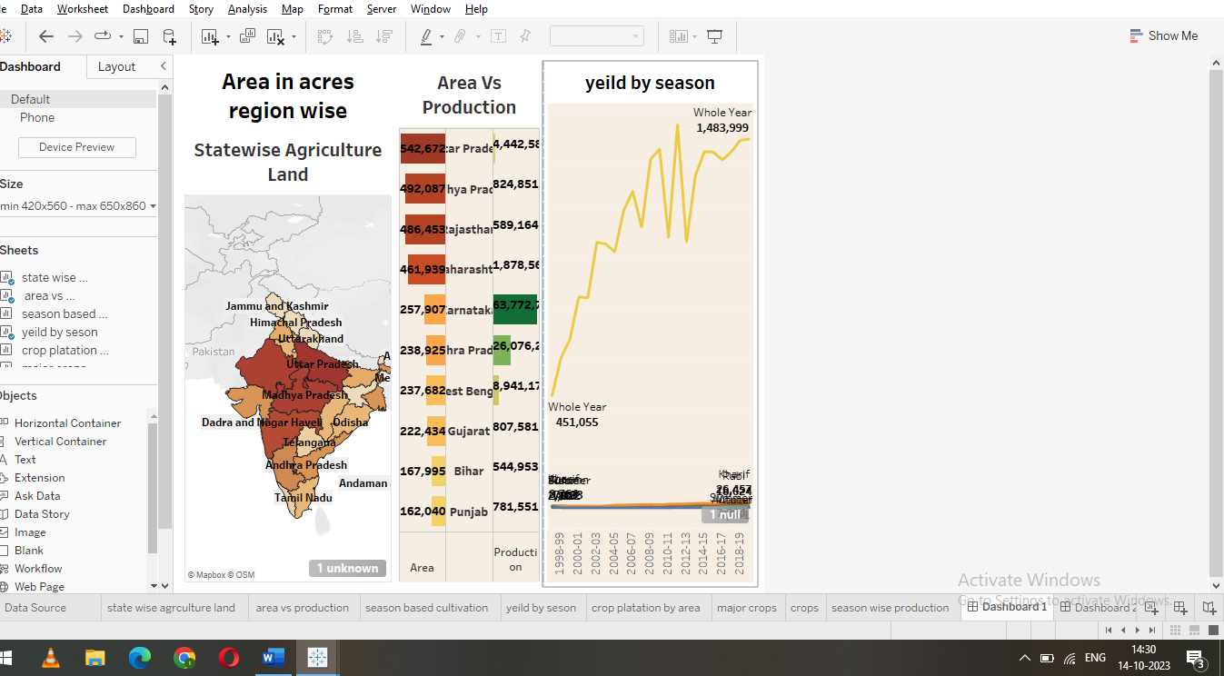

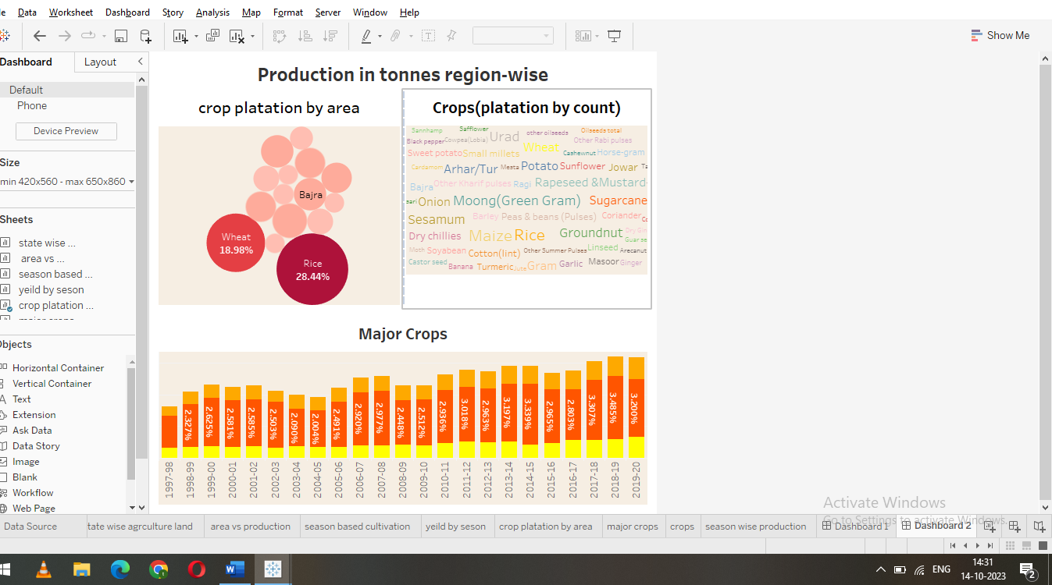

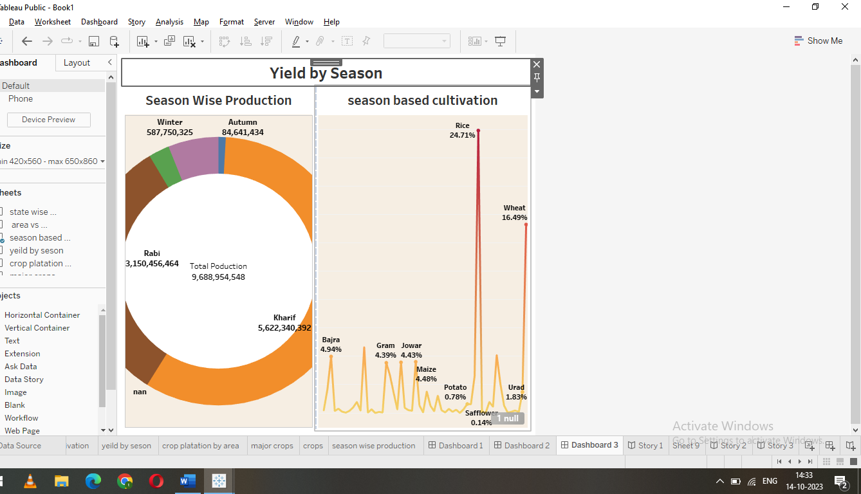

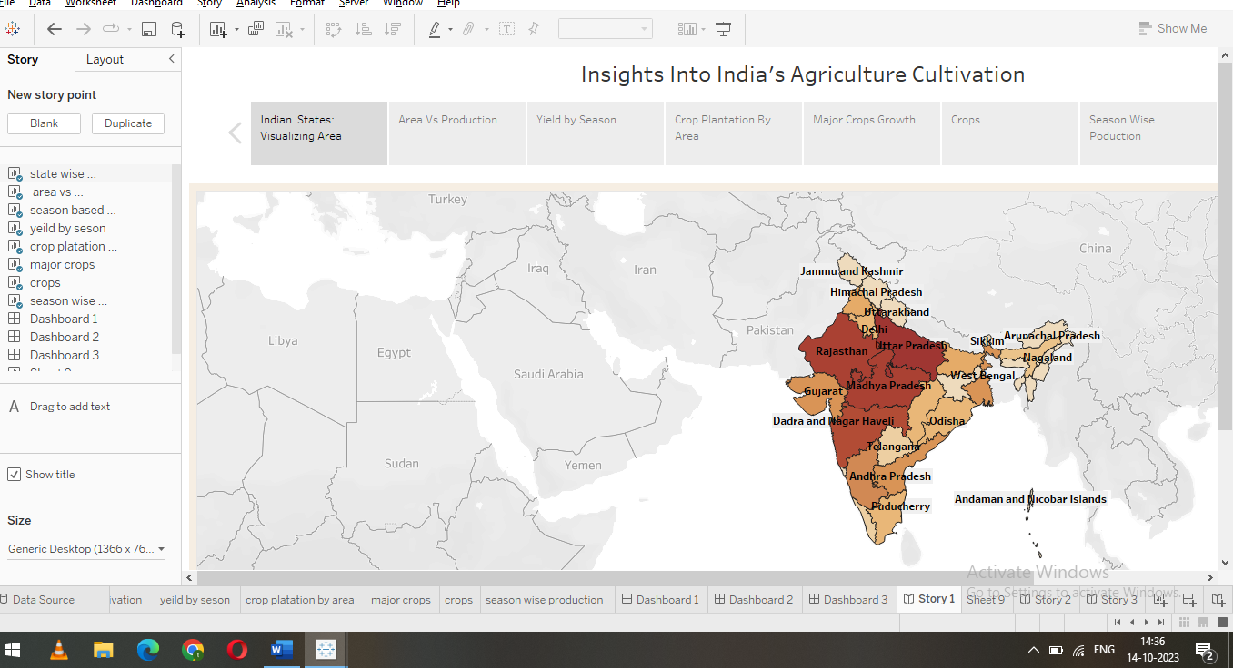

4.Advantadge&disadvantadge

\*advantadge

Reduced cost on the farm ,saving in time ,human labour and machinery.increased soil fertiling retention of moisture leading to long term increasase in yield reduction of variation in yield and higher security of food production.

\*Disdvantadge

Acquisitio ofspecialized machinery fo seeding and planting. Short term problems with pests due to changes in crop cultivation. High risk for farmers due to the technological uncertainties.development of appropriate technical package and training

6.Conclusion.

The Indian economy is an agro-economy and depends highly on the agricultural sectors despite just supporting the Indian economy,the agricultural sector

7.Future scope

Due to globalization ,increase in household incomes and health consciousness the demand for fruits and vegtables ,dairy products,fish and meat is going to to increase in future.